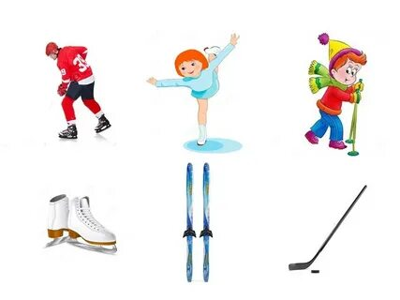



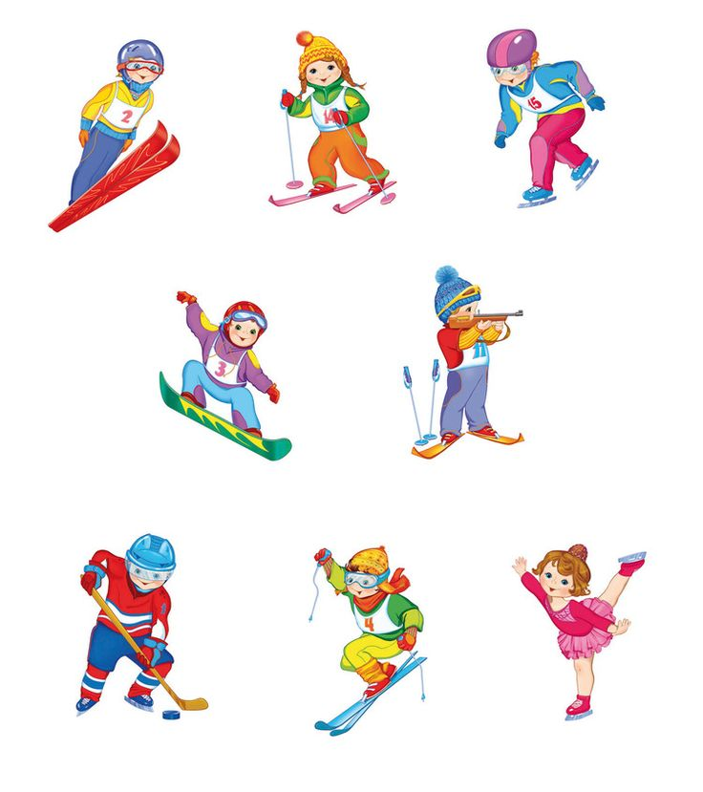

|  |  |  |
| --- | --- | --- |
| https://avatars.mds.yandex.net/get-zen_doc/4473624/pub_6074196e7a826a210abbda4e_60741979fe84f84e632b5877/scale_1200 | | https://avatars.mds.yandex.net/i?id=2a1144db89b33f7690c2ffe5b05e1eb0-5843587-images-thumbs&n=13 |
|  |  | |